19.NFA-NO OF B’S

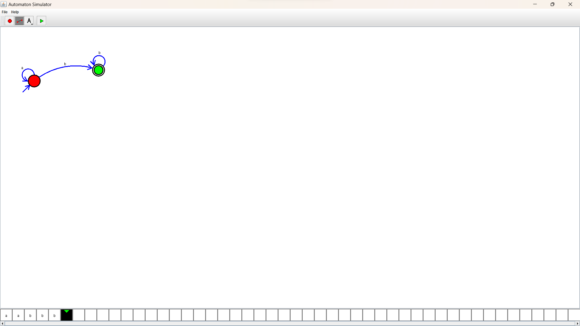Design :

Output:

